**Level 1: PC Tower Case**

**Outline**

Learn about the internals of a standard PC case by examining physical samples and selecting and labeling images found on-line. Gain deeper knowledge by researching and reporting on specific components.

**Questions**

1. Find one (or more) images that clearly show the internals of a PC Tower Case.   
   (i.e. Google images using keywords “PC Case Internals”)

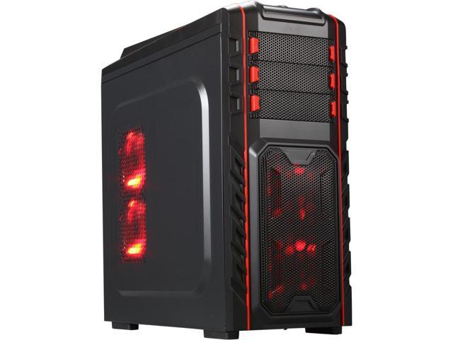

1. Clearly label the following components (using arrows) on your image of the PC case internals:
   1. Motherboard

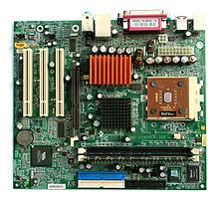

* 1. Power Supply

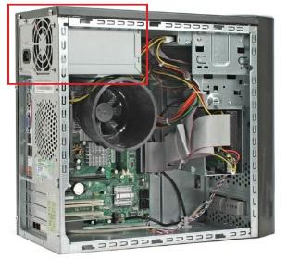

* 1. Hard Disk Drive
  2. Optical Disk Drive (e.g.DVD)

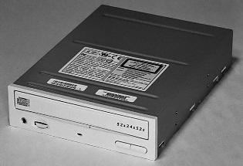

* 1. USB Expansion Ports
  2. Monitor Port
  3. Audio Ports

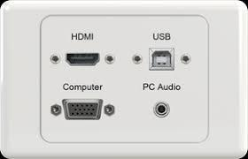

* 1. Ethernet Port

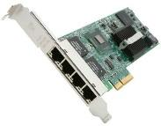

* 1. Cooling Fan

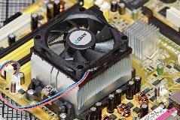

1. Research more in-depth about “Motherboards”. Make notes on the following:
   1. What different versions are currently available (speed and capacity)

Types of Motherboards. Motherboards come in different sizes, known as form factors. The most common motherboard form factor is ATX. The different types of ATX are known as micro-ATX.

* 1. How the component has changed since the 1980’s

The Central Processing Unit (CPU), memory, and peripherals were housed on individual printed circuit boards, which were plugged into the backplane. During the late 1980s and early 1990s, it became economical to move an increasing number of peripheral functions onto the motherboard.  The IBM Personal Computer featured the first motherboard.

1. Research more in-depth about “Hard Disk Drives”. Make notes on the following:
   1. What different versions are currently available (speed and capacity)

IBM 350 RAMAC, capacity 5Mb.

An EIDE Hard Disk Drive. A hard disk drive(PATA type) | Source.

Interface of SATA Drive. A SATA Hard Disk Drive Pin Out | Source.

A Solid State Drive (SSD)

* 1. How the component has changed since the 1980’s

The IBM 350 Disk File was developed under the code-name RAMAC by an IBM.

It was announced in 1956 with the then new IBM 305 RAMAC computer. The IBM 350 drive had fifty 24-inch (0.6 m) platters, with a total capacity of five million 6-bit characters (3.75 megabytes).

**Level 2: PC Motherboard**

**Outline**

Learn about the structure of a standard PC motherboard by examining physical samples and selecting and labeling images found on-line. Gain deeper knowledge by researching and reporting on specific components.

**Questions**

1. Find one (or more) images that clearly show the layout of a PC Motherboard.   
   (i.e. Google images using keywords “PC Motherboard”)  
   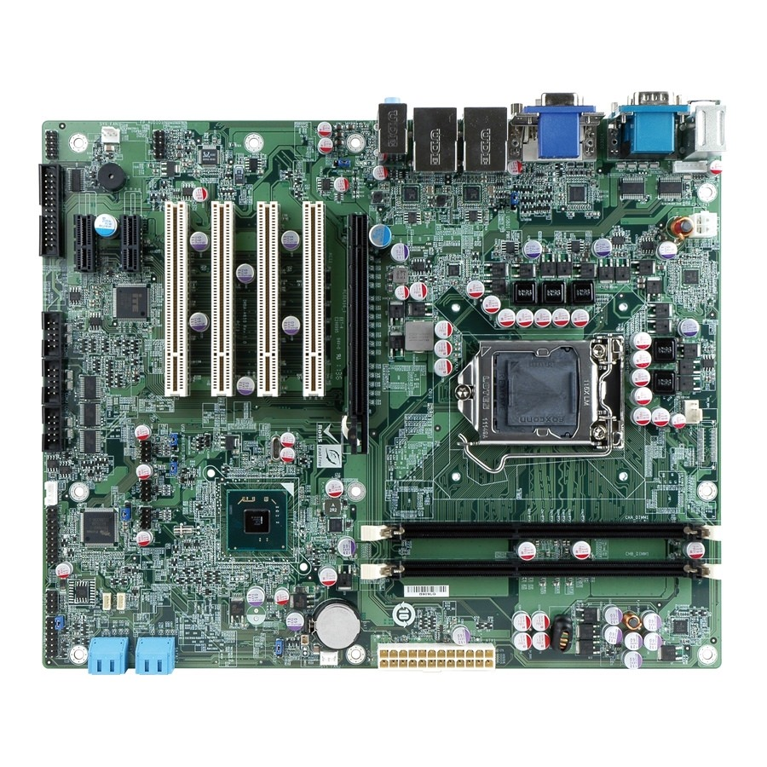
2. Clearly label the following components (using arrows) on your image of the PC motherboard:
   1. CPU (and fan)

Image result for motherboard cpu 

* 1. RAM Memory

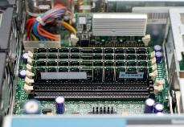

* 1. Disk Drive Interface (IDE or SATA)
  2. GPU Graphics Processor (either on-board or Graphics Card)

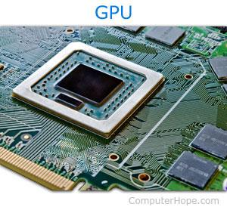

* 1. Sound Processor (either on-board or Sound Card)

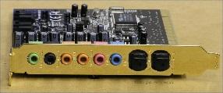

* 1. Wi-Fi / Ethernet Network Interface (either on-board or Graphics Card)



1. Research more in-depth about “CPU Processor Chip”. Make notes on the following:
   1. What different versions are currently available (speed and capacity)

Budget processors. AMD Sempron. Intel Celeron.

Mainstream processors. AMD Athlon 64. Intel Pentium 4.

Dual-core processors. AMD Athlon 64 X2. Intel Pentium D.

AMD and Intel processor summaries.

* 1. How the component has changed since the 1980’s

1971 Intel publicly introduced the world's first single chip microprocessor called the Intel 4004.

Initially the 4000 chipset consisted of 4 chips—4004, 4001 (ROM), 4002 (RAM), 4003 (shift register)

1. Research more in-depth about “RAM Memory”. Make notes on the following:
   1. What different versions are currently available (speed and capacity)

In early 2012, a new Mac might be equipped with 4 GB of memory and a hard drive whose storage capacity is 500 GB. The primary reason for this great disparity is cost. Memory, RAM, is much more expensive then hard drive storage space.

* 1. How the component has changed since the 1980’s  
     RAM is available in different quantity (4GB, 8GB...) and speeds such as 1600 Mhz, 1333 Mhz.

**Level 3: Peripheral Devices**

**Outline**

Learn about how peripheral devices are connected to the back side of a typical PC tower case. Examine physical samples, select and labeling images found on-line and gain deeper knowledge by researching and reporting on specific components.

**Questions**

1. Find one (or more) images that clearly show the layout of the back of a typical PC tower case.   
   (i.e. Google images using keywords “Back Of PC Tower”)  
   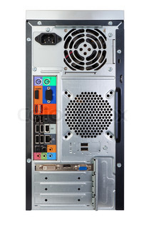
2. Clearly label the following components (using arrows) on your image of the back of a typical PC tower case:
   1. Power cord and power switch

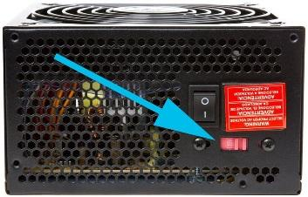

* 1. Monitor Interface (VGA or DVI or HDMI)

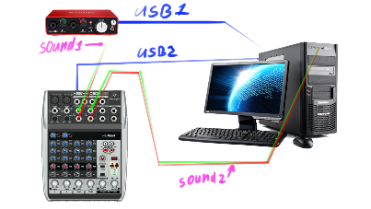

* 1. Mouse Interface (USB or PS/2)  
     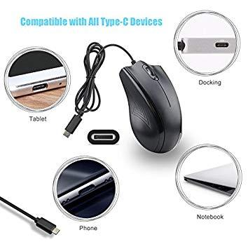
  2. Keyboard Interface (USB or PS/2)

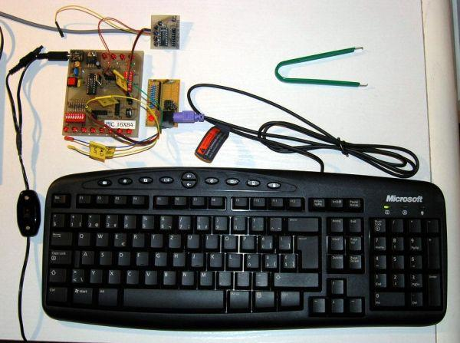

* 1. USB Ports

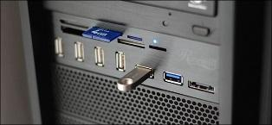

* 1. Audio Inputs / Outputs



* 1. Ethernet Interface



1. Research more in-depth about “Monitor Technology”. Make notes on the following:
   1. What different versions are currently available (e.g. VGA / DVI, Flat Panel Technology))

Often referred to as a monitor when packaged in a separate case, the display is the most-used output device on a computer. The display provides instant feedback by showing you text and graphic images as you work or play.

Most desktop displays use [liquid crystal display](https://electronics.howstuffworks.com/lcd.htm) (LCD) or [cathode ray tube](https://electronics.howstuffworks.com/tv1.htm) (CRT) technology, while nearly all portable computing devices such as [laptops](https://computer.howstuffworks.com/laptop.htm) incorporate LCD technology. Because of their slimmer design and lower energy consumption, monitors using LCD technology (also called flat panel or flat screendisplays) are replacing the venerable CRT on most desktops.

1. Research more in-depth about “External Portable Storage”. Make notes on the following:
   1. Floppy Disks

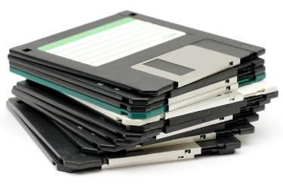

* 1. CD-ROM / DVD / Recordable CD/DVD

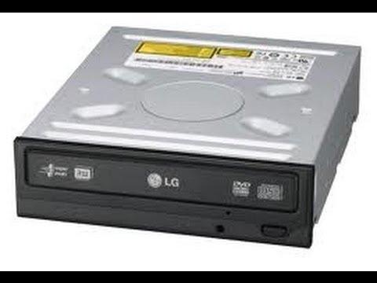

* 1. USB Memory Drives

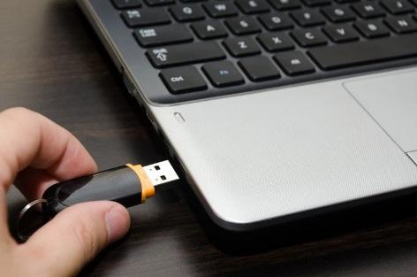

* 1. Compact Flash Memory

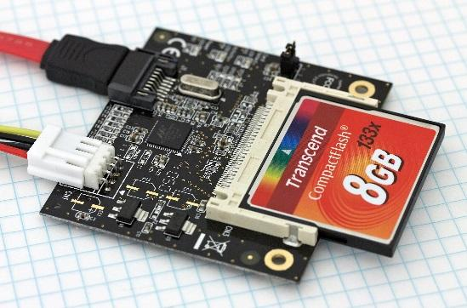

* 1. Cloud Based Storage  
     